
Tertiary Infotech Academy Pte Ltd
UEN: 201200696W
PRACTICAL PERFORMANCE (PP) — ANSWER KEY
For
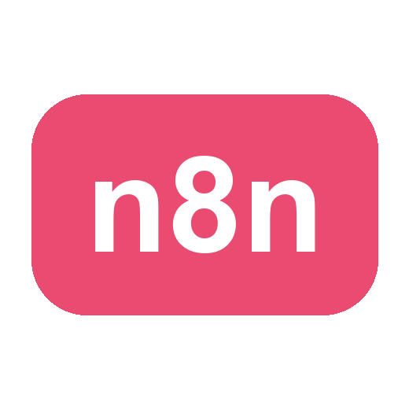
Agentic AI Automation with n8n
TGS Ref No: TGS-2023035977
Conducted by
Tertiary Infotech Academy Pte Ltd
UEN: 201200696W
Version v12

DOCUMENT VERSION CONTROL RECORD
Version Number | Effective Date of Release | Summary of Included Changes | Author
v11 | Prior | Baseline practical-assessment answer key | Tertiary Infotech Academy Pte Ltd
v12 | 1 July 2026 | Rewrote model answers as the lab build steps for each task and cited the activities | Tertiary Infotech Academy Pte Ltd

Agentic AI Automation with n8n
Answers to Practical Performance Assessment
Course Code: TGS-2023035977
C: Practical Problem
Scenario
FryTech Appliances is a fast-growing electronics company selling air-fryer products through e-commerce platforms, retail distributors and corporate/bulk channels. As demand grows, so does the volume and complexity of customer interactions — pre-sales enquiries, post-sales support, warranty claims and logistics. Leadership decides that simple forms and autoresponders are no longer enough and adopts agentic AI-driven workflows, orchestrated in n8n, to improve efficiency, scalability and customer satisfaction. Complete the tasks below, each mirroring an automation you built in class.
Task 1 (LO1):
FryTech receives a high volume of repetitive customer enquiries (pricing, wattage, capacity, warranty). Design and implement an automated customer-enquiry workflow in n8n. It must capture enquiries from a web Form, record the details in a Data Table (or Google Sheets), send a confirmation email to the customer, and notify the sales/support team — using conditional logic where appropriate. Publish the form and turn its URL into a QR code.
Show the screenshot of the n8n workflow in the box below
Suggestive answers (not exhaustive):
• Add a Form Trigger with fields (Name, Email, Phone, Enquiry) — as in Activity 1.
• Add a Gmail node to email the team and a second Gmail node to send the customer a confirmation.
• Add a Data Table (Insert Row) — or Google Sheets — to store each submission (Activity 2 / 3b).
• Optionally add an IF node to route by enquiry type / attending (Activity 3a).
• Save & Activate; copy the Form production URL and generate a QR code for it (Activity 1).

Task 2 (LO2):
FryTech wants a chatbot that answers team-member and customer questions about product specifications. Design and deploy an AI agent (in Telegram or embedded in a web page) that uses an LLM with memory and at least one tool to answer questions grounded in company data.
Show the screenshot of the n8n workflow in the box below
Suggestive answers (not exhaustive):
• Add a Telegram Trigger (Activity 4a) or a Webhook for a website chatbot (Activity 5).
• Add an AI Agent with a Chat Model (OpenAI/Gemini) and a Simple Memory (window buffer).
• Attach a tool — a Data Table tool for product/spec lookups (Activity 4b) — and write a System Instruction.
• Send the reply back (Telegram Send Message, or Respond to Webhook for the website).
• Save & Activate; test with a product question and confirm a grounded reply.

Task 3 (LO3):
FryTech wants staff to query internal documents (product manuals / IT-Support FAQ / policies) in natural language. Build a Retrieval-Augmented Generation (RAG) workflow: users upload documents which are embedded and stored in a vector store, and an AI agent retrieves the most relevant chunks and answers strictly from them.
Show the screenshot of the n8n workflow in the box below
Suggestive answers (not exhaustive):
• Ingestion: an upload point → Embeddings → Vector Store (Insert) with a Default Data Loader (Activity 7a).
• Upload a document (e.g. the IT-Support FAQ PDF) from the web uploader into the vector store.
• Chat: an AI Agent with the Vector Store exposed as a retrieve-as-tool (knowledge_base) answers only from retrieved chunks (Activity 7a).
• For persistence, ingest into a vector database — Supabase / Pinecone / Qdrant — matching the 1536 embedding dimension (Activity 7b).
• Test: ask a question answerable only from the document; confirm a grounded answer.

Task 4 (LO4):
FryTech must integrate with external systems. Build a workflow that either (a) uses a Webhook to receive data from an external web page and respond to it, or (b) uses an HTTP Request to query an external API (e.g. market or news data) and use the result. When run, show the data is received/queried correctly.
Show the screenshot of the n8n workflow in the box below
Suggestive answers (not exhaustive):
• Option A — Webhook (Activity 5): add a Webhook (CORS = *), process the request, and reply with Respond to Webhook; call it from a web page.
• Option B — HTTP Request (Activity 6): call an external API with method, headers and query parameters; store the API key in a credential.
• Use the returned JSON in downstream nodes (e.g. feed it to an AI Agent).
• Save & Activate; run it and show the collected/queried data in the execution.

Task 5 (LO5):
FryTech must secure its AI agent against prompt injection and data leaks. Build a guardrail that protects the agent: an input guardrail that classifies each message ALLOW/BLOCK before the agent (and, optionally, an output guardrail on the reply, or a human-in-the-loop approval step).
Show the screenshot of the n8n workflow in the box below
Suggestive answers (not exhaustive):
• Add a Webhook → an LLM Chain 'Input Guardrail' that replies ALLOW or BLOCK (Activity 8c).
• Add an IF node on the result: BLOCK → Respond with a safety message; ALLOW → continue to the AI Agent.
• Optionally add an 'Output Guardrail' LLM Chain (SAFE/LEAK) before Respond to Webhook.
• Optionally add a human-in-the-loop approval (Gmail Send-and-Wait) for sensitive actions (Activity 8a).
• Test: a normal question passes; 'ignore previous instructions…' is blocked.

